**EARTHQUAKE RESISTANCE STRUCTURE REPORT**

**WHAT IS AN EARTHQUAKE?**

* EARTHQUAKES ARE CAUSED DUE TO SUDDEN LATERAL OR VERTICAL MOVEMENTS IN THE CRUST OF THE EARTH OR WE CAN SAY THAT WHEN TECTONIC PLATES RIDE OVER THE ORTHER AND CAUSE THE COLLISION OF OROGENY OR MOUNTAIN BUILDING.
* THE LARGEST FAULTS ARE FORMED ON THE SURFACE OF THE EARTH DUE TO BOUNDARIES BETWEEN MOVING PLATES.
* THEY ARE NATURAL DISASTERS OF A GENERALLY UNPREDICTABLE NATURE.
* IT IS SHAKING OF THE EARTH,DUE TO THE MOVEMENT OF EARTH CRUST.

**CAUSES FOR EARTHQUAKE:**

* TECTONIC EARTHQUAKE OCCURS WHEN DUE TO GEOLOGICAL FORCE ON ROCKS AND THE ADJOINING PLATES CAUSES PHYSICAL AND CHEMICAL CHANGES AND RESULTS IN THE BREAKING OF THE EARTH CRUST.
* VOLCANIC EARTHQUAKE RESULTS FROM TECTONIC FORCES AND OCCURS IN CONJUNCTION WITH VOLCANIC ACTIVITY.
* COLLAPSE EARTHQUAKE ARE GENERALLY SMALL EARHQUAKE THAT OCCURS IN UNDERGROUND CAVERNS AND MINES CAUSED BY SEISMIC WAVES WHICH ARE PRODUCED FROM THE EXPLOSION OPF ROCK ON THE SURFACE.
* EXPLOSION EARTHQUAKE OCCURS DUE TO THE DETONATION OF A NUCLEAR OR CHEMICAL DEVICE.

**TYPES OF EARTHQUAKES:**

* BODY WAVES: BODY WAVES IS A SEISMIC WAVE THAT MOVES THROUGH THE INTERIOR OF THE EARTH. THEY ARE DIVIDED INTO TWO TYPES:

1. P-WAVES: IT’S KNOWN AS PRIMARY WAVES. THEY TRAVEL AT THE GREATEST VELOCITY THROUGH THE EARTH. IT CAN MOVE THROUGH ROCK, SOLID AND FLUIDS.

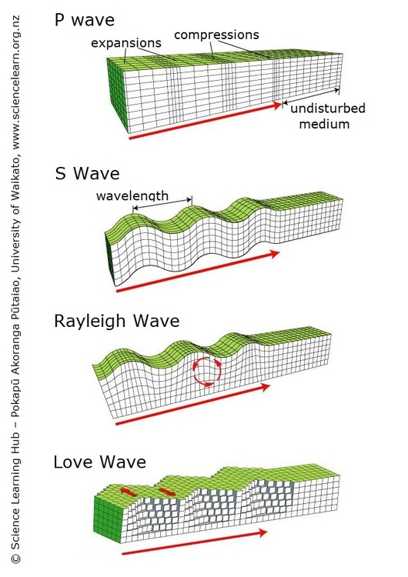

1. S-WAVES: IT’S KNOWN AS SECONDARY WAVES. THEY TRAVEL LOWER THAN P-WAVES. IT TRAVELS THROUGH SOLIDS ONLY.



* SURFACE WAVES: SURFACE WAVES TRAVEL JUST UNDER THE EARTH’S SURFACE.THEY CAN BE MUCH LARGER IN AMPITUDE AND CAN BE THE MOST DESTRUCTIVE TYPE INSPITE OF BEING SLOW.

1. LOVE: IT’S THE FASTEST SURFACE WAVES AND MOVES THE GROUND SIDE TO SIDE. THESE WAVES PRODUCE ENTIRELY HORIZONTAL MOTION.



1. RAYLEIGH: A RAYLEIGH WAVE ROLLS ALONG THE GROUND JUST LIKE A WAVE ROLLS ACROSS A LAKE OR AN OCEAN. BECAUSE IT ROLLS, IT MOVES THE GROUND UP AND DOWN, AND SIDE TO SIDE IN THE SAME DIRECTION THAT THE WAVE IS MOVING.



**DESIGN CRITERIA FOR EARTHQUAKE RESISTANT STRUCTURES:**

* SIMPLER THE PLAN BETTER THE PREFORMANCE.
* RCC PEFERABLE THAN PCC.
* STRONG COLUMN WEAK BEAMS.
* AVOID SOFT STOREY /RATHER PROVIDE CONTINUE WALLS ON GROUND STOREY.
* HORIZONTAL BAND NECESSARY THROUGHOUT THE MANSORY.

**STRUCTURAL CRITERIA FOR EARTHQUAKE RESISTANT STRUCTURES:**

* COMPACT THE CONCRETE BY MEANS OF NEEDLE VIBRATOR.
* CURE THE CONCRETE FOR AT LEAST A MINIMUM PERIOD.
* EXPERIENCED SUPERVISOR SHOULD BE EMPLOYED TO HAVE.
* GOOD QUALITY CONTROL AT SITE.

**TECHNIQUES USED FOR EARTHQUAKE RESISTANT STRUCTURE:**

**BASE ISOLATION:**

* INTRODUCES FLEXIBILITY TO THE STRUCTURES.
* BUILDING IS RESTED ON FLEXIBLE PADS (BASE ISOLATORS).
* WHEN EARTHQUAKE STRIKES BUILDING DOES NOT MOVE.
* IT IS SUITABLE FOR HARD SOIL ONLY.

1. LEAD RUBBER BEARING :

* FREQUENTLY USED FOR BASE ISOLATION.
* MADE FROM LAYERS OF RUBBER SANDWICHED TOGETHER WITH LAYERS OF STEEL.
* VERY STIFF AND STRONG IN THE VERTICAL DIRECTION.
* FLEXIBLE IN HORIZONTAL DIRECTION.

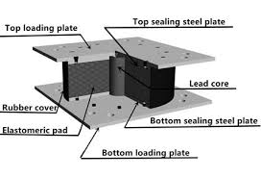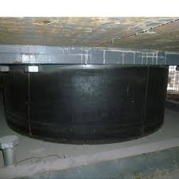

1. SPHERICAL SLIDING ISOLATOR :

* IT USES BEARING PADS THAT HAVE A CURVED SURFACE AND LOW FRICTIO MATERIAL SIMILAR TO TEFLON.
* DURING AN EARTHQUAKE THE BUILDING IS FREE TO SLIDE BOTH HORIZONTALLY AND VERTICALLY.
* IT WILL RETURN TO ITS ORIGINAL POSITION AFTER THE GROUND SHAING STOPS.

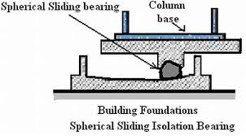

ROLLERS:

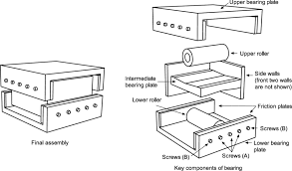

VISCOUS DAMPER:

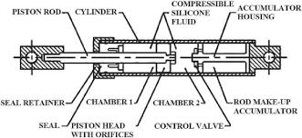

FRICTION DAMPER:

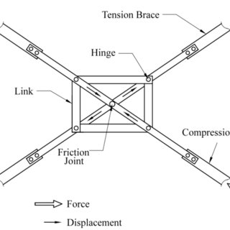

YEILDING DAMPER:

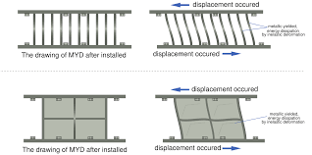

VISCOELASTIC DAMPER:

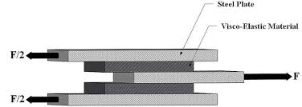

TUNED MASS DAMPER:

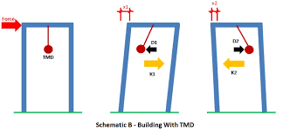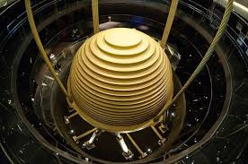

**ADVANTAGES:**

* THIS IS TO PROTECT THE PRIMARY STRUCTURE FROM DAMAGE.
* AVOIDING DANGEROUS BUILDING COLLAPSE.
* BASE ISOLATION WILL ENHANCE OCCUPANT SAFETY DURING A MAJOR EARTHQUAKE AND PROJECT THE BUILDING CONTENTS.
* A RESILIENT BUILDING MAY ALLOW YOU EARLY OCCUPATION AFTER AN EARTHQUAKE AND BUISNESS CONTINUITY.
* IT CAN INCREASE STAFF CONFIDENCE.

**DISADVANTAGES:**

* AN EARTHQUAKE CAUSES COURSE DEATH AND DESTRUCTION OF ROAD AND HOUSES AND BUILDING.
* THEY CAN MAKE BUILDING FALL DOWN AND SET OFF LANDSLIDES, AS WELL AS HAVING MANY OTHER DEADLY EFFECTS.
* HIGHER NUMBER ON THE SCALE THE MORE POWERFUL THE QUAKE THE MORE POWERFUL A QUAKE IS MORE DAMAGE IT CAN CAUSE.

**CASE STUDY:**

PHILIPPINES ARENA

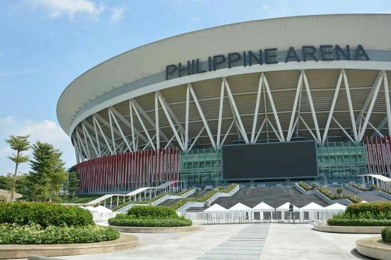

**LOCATION:** CIUDAD DE VICTORIA, SANTA MARIA, BULACAN, PHILIPPINES 30 KM NORTH OF MANILA.

**ABOUT:**

* ONE OF THE LARGEST ARENA IN THE WORLD.
* CAPACITY OF ARENA:50,000
* EARTHQUAKE RESISTANT STRUCTURE
* WIND AND FLOOD RESISTANT STRUCTURE
* THE LARGEST NON-COLUMN AREA IN THE WORLD, MEASURED TO BE AROUND 227 M × 179 M.
* INSPIRED BY THE TRADITIONAL FILIPINO NIPA HUT AND THE INDIGENOUS NARRA TREE, THE PHILIPPINE ARENA SYMBOLISES THE ENDURANCE, STRENGTH AND INDOMITABLE SPIRIT OF THE PEOPLE.
* ARCHITECTURE FIRM: POPULOUS
* CONSTRUCTED BY 14TH MAY 2014 ( DURATION: 3 YEARS )

**MAJOR PROBLEMS:**

* CAPACITY: THE PHILIPPINES’ CAPITAL OF MANILA IS THE WORLD’S MOST DENSELY POPULATED CITY, AND ANCHORS A METROPOLIS OF MORE THAN 12 MILLION PEOPLE.
* LOCAL FOCAL POINT: IT IS DIFFICULT TO GIVE 50,000 PEOPLE A GOOD VIEW OF A SINGLE FOCAL POINT AND CREATE AN INTIMATE ATMOSPHERE.
* CLIMATE AND EARTHQUAKE ZONE: EARTHQUAKES – SOME AS POWERFUL AS 8.2MW ON THE RICHTER SCALE – FREQUENTLY ROCK THE PHILIPPINES. SUCH SEISMIC ACTIVITY IGNITES VOLCANOES AND SUMMONS TSUNAMIS. GALE-FORCE WINDS FROM TROPICAL TYPHOONS TEAR ACROSS THE LANDSCAPE.
* MULTI-PURPOSE ARENA: A FACILITY OF THIS SIZE ALSO NEEDS TO AVOID FEELING EMPTY DURING SMALLER EVENTS. IT NEEDS TO HOLD DIFFERENT EVENT AT THE SAME VENUE.
* SAFE POINTS: THE DESIGN HAD TO ENABLE LARGE CROWDS TO ENTER AND EXIT THE ARENA QUICKLY AND SAFELY, AND ACCOUNT FOR MANILA’S HUMID, TROPICAL CLIMATE AND LOCATION IN AN EARTHQUAKE ZONE.

**HOW CHALLENGES ARE APPROACED:**

* HIGH CAPACITY OF ARENA:

LARGEST NON-COLUMN ARENA

CAPACITY: 50,000 + LIVE SITE 50,000

ELLIPTICAL DOME ROOF WITH GRID SYSTEM SPACE FRAME

DIMENSIONS: 227 M × 179 M

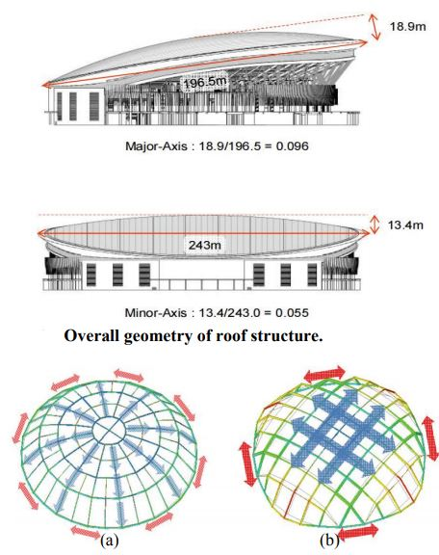

* CLEAR VIEW FOR ALL:

ONE-SIDED BOWL

FOCAL POINT IN ONE DIRECTION

SIMILAR DESIGN LIKE A THEATER

CENTRAL STAGE WITH VIDEO BOARD OF EITHER SIDES OF STAGE.

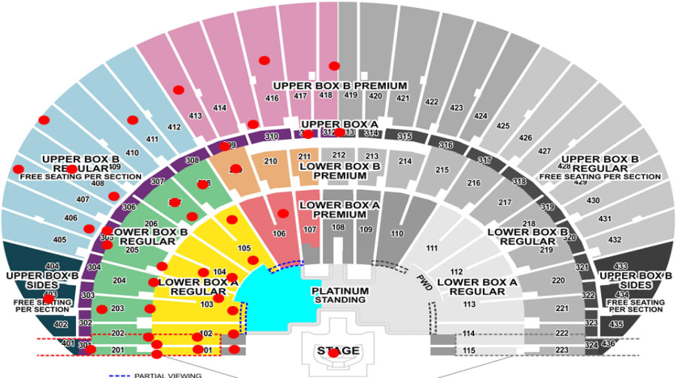

* CLIMATIC CONDITIONS AND EARTHQUAKE ZONE:

DUAL SYSTEM & LRB

FULLY AIR CONDITIONED

RC BEAM & GIRDER SYSTEM

LEAD RUBBER BEARING

WIND TEST ON STEEL SPACE FRAME

THE SHEAR WALLS AND THE GIRDER SYSTEM SHARED THE LATERAL FORCES DURING A MODEL TEST.

THUS IT CAN TAKE ON STANDARD SEISMIC FORCES.

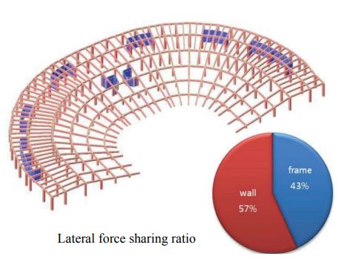

* LARGE OR SMALL CROWD:

TWO SEPARATED BOWLS

TO RETAIN INTIMACY DURING SMALLER EVENTS, THE LOWER BOWL IS THE MOST FREQUENTLY USED PART OF THE BUILDING. IT CAN BE EASILY SEPARATED FROM THE UPPER TIER THROUGH CURTAINING WITH ACOUSTIC AND THERMAL PROPERTIES.

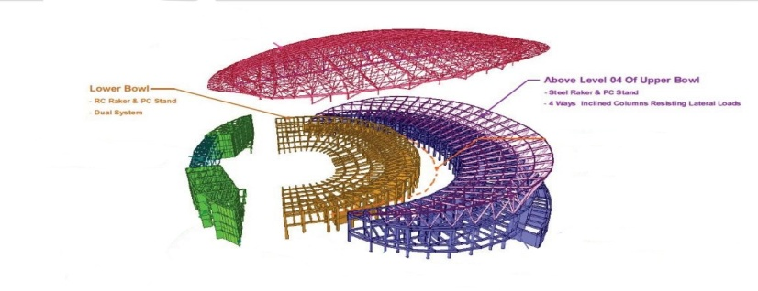

* CROWD FLOW:

TO COPE WITH LARGE NUMBERS ARRIVING FOR AN EVENT SIMULTANEOUSLY, THE ARENA’S ENTRANCES IMMEDIATELY REDIRECT PEOPLE TO CLEAR PATHWAYS.

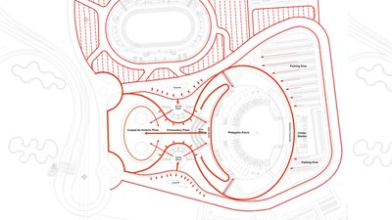

STRUCTURAL DETAILS:

* DIMENSIONS:

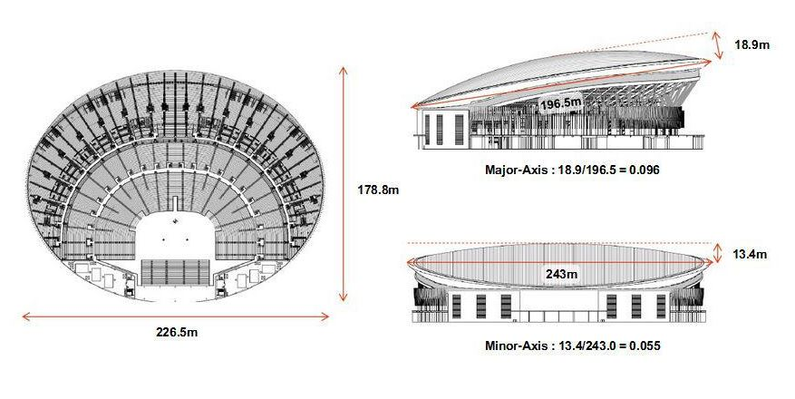

* OVERVIEW: 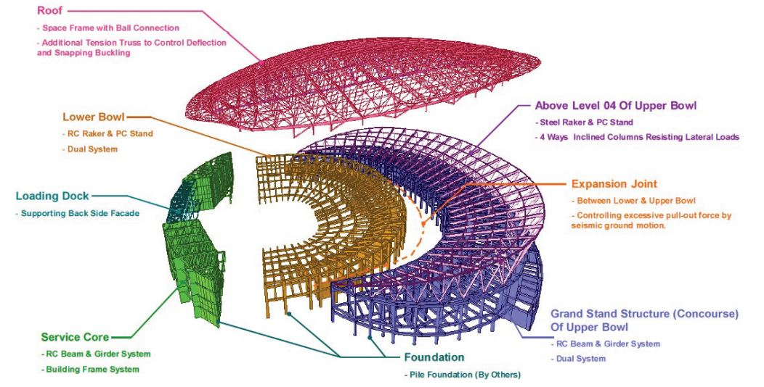
* 4 WAY INCLINED COLUMN:

2 COLUMNS JOINED TO THE RING OF THE ROOF AND 2 COLUMNS JOINED TO INCLINED PRE-CAST SANDWHICH PLATE SYSTEM STAND.

ALL COLUMNS CONNECTED AT THE BASE BY ISOLATOR- LRB( LEAD RUBBER BEARING)

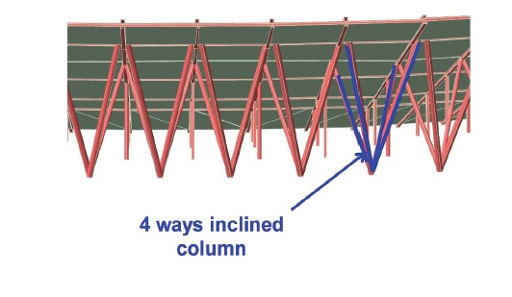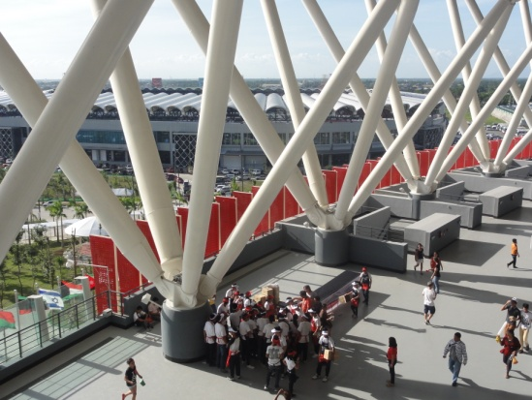

**CONCLUSION:**

* IN EARTHQUAKE RESISTANT BUILDING IS EARTHQUAKE DISTROY THE BUILDING, MONEY AS WELL AS LIFE TOO.
* MAIN MOTIVE TO DESIGN THE EARTHQUAKE RESISTANT STRUCTURE TO SAVE PEOPLES LIFE AS WELL AS WEALTH.